West Virginia’s Public Defender System: A Comparative Study of Compensation Rates

West Virginia Law Institute
February 2018

Levi Pellegrin
Associate Researcher

The prominent issue concerning Public Defender Services (PDS) in West Virginia is the growing discrepancy between Appointed Counsel’s convention of persistent overbilling practices and the legislature’s disinclination to adjust compensation rates to fairly reflect the economic demands of representing indigent defendants to constitutional standards. This is not the first time West Virginia has had this issue, and it is not the first time West Virginia has addressed it either, but the reality of the way West Virginia has been dealing with the issue providing legal services indigent criminal defendants may be indicative of a more implicit fundamental issue in the law that has caused perennial administrative problems.
Between January 2013 and the end of the 2015 fiscal year, there were 183 reported instances of attorneys billing the state for more than 24-hours in a single day for legal services. The story gained attention from national media outlets who made a mockery of West Virginia’s legal community. PDS has an incentive to downplay the story as a few bad apples, but unfortunately the enormity of the issue is more than a mere perception of the legislature and a comical headline. A ten-year analysis of the total number of claims paid to Appointed Counsel each year and the total number of cases closed by their counterpart, the Public Defender Corporation, versus the total number of hours billed by Appointed Counsel and the total number of hours registered by the Public Defender Corporation, indicates that there is a sizable and growing discrepancy in the amount of work actually being performed for a relatively similar number of cases.
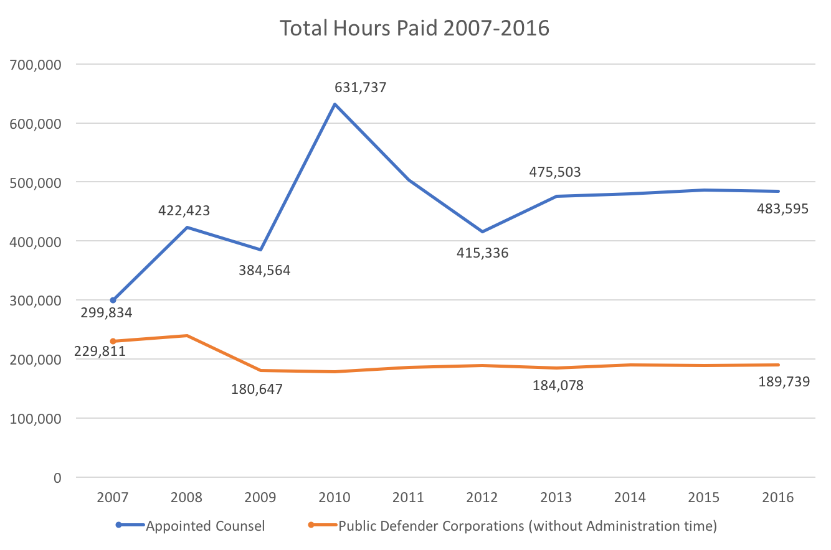
Figure 1
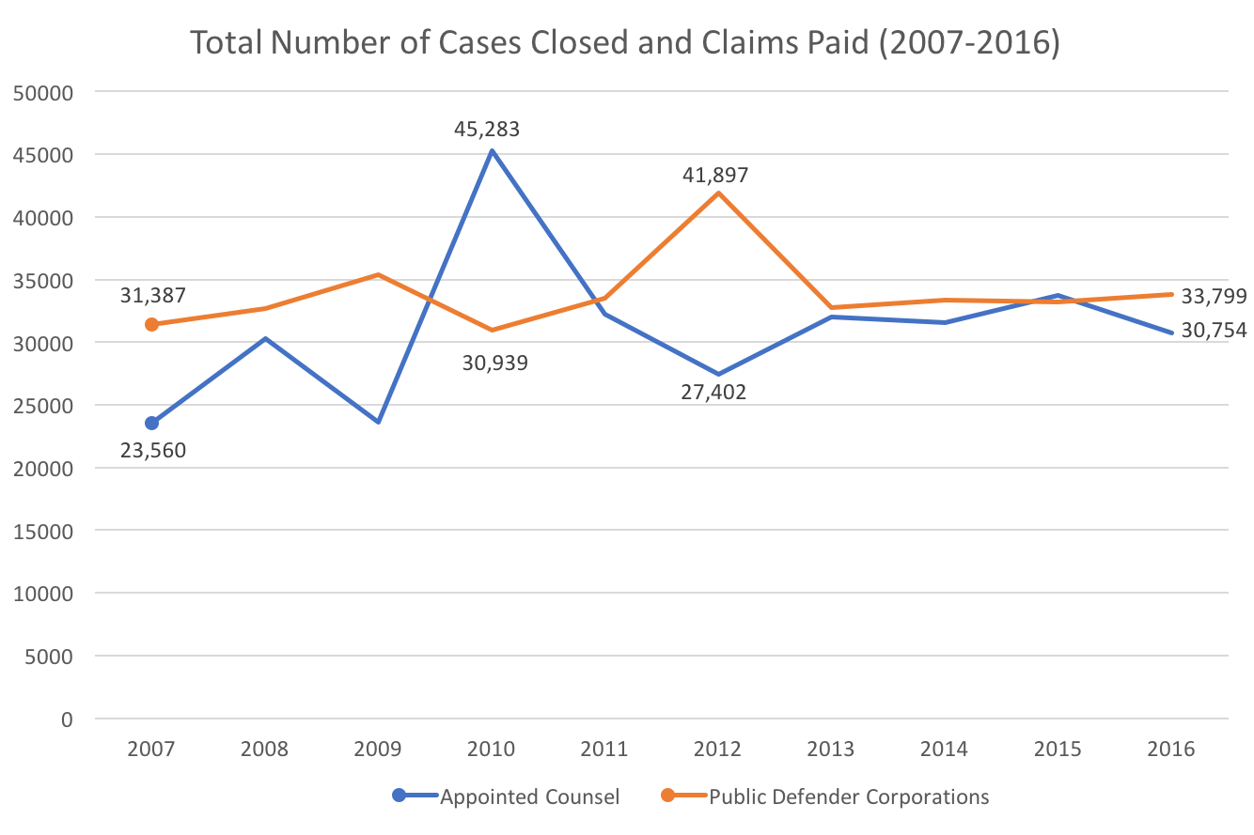
Figure 2
The data provided by the West Virginia Public Defenders Services Annual Reports create fairly odd-looking data trends because the organization implemented some adjustments in the accounting and reporting practices since FY 2013, and a complication in the voucher system in FY 2009 - FY 2010 caused many vouchers intended for 2009 to be delayed until the following year, causing a lopsided contrast in the appearance of data reported for those two years. That is not to say, however, that the data are unusable. The overall narrative to be gleamed from comparing these two graphs is just as valid despite small itemized errors in accounting. Notice in 2007, how relatively close the data sets are to each other versus the trend over ten years. The total number of hours billed for by Appointed Counsel has increased 61% in the last ten years, while the total number of claims themselves has only increased by 30%. On the other hand, Public Defender Corporation’s total number of hours has decreased by 17% in the last ten years and the number of cases closed increased 7%, a seemingly steadier improvement, which is highlighted by the fact that in FY 2016, the statewide average cost per case for Appointed Council was $764.92, while the average cost per case for PDC was $562.65.
It could be that the large discrepancy is the result of Appointed Counsel taking an increased burden of complex cases that simply require more time to complete, such as serious felonies and termination of parental rights/abuse & neglect cases, while Public Defender Corporations reciprocated by undertaking the breadth of misdemeanors and lower level offenses, which on average require far less time to see through to completion and are more efficiently administered on account of PDC lawyers who usually specialize in criminal law and so do not require as much time to research more routine offenses. This is likely true to some degree, although it is difficult to know for sure to what length because PDCs are not required to keep track of their time by case type like Appointed Counsel do on voucher claims. PDCs are full-time salaried employees of the Corporation, therefore it is difficult to compare in more depth the efficiencies of the two systems by this measure because we do not have the data for PDCs reported for each year.
Just looking at Appointed Counsel data over the last decade in more depth, compare in Figure 3 and Figure 4 two case types generally considered to be more complex and time consuming (Felonies, Termination/Abuse & Neglect) and a case type considered to be more routine and less time consuming (Misdemeanors). The number of hours in felony cases has increased 66%, while the number of claims has increased 40%, a ratio of nearly 3:2. The number of hours for Termination/Abuse & neglect cases has increased a dramatic 94% while the number of claims has increased 57%, a ratio that closer resembles 2:1. However, misdemeanor hours billed have only increased 18%, somewhat proportional to the 13% increase in the number of misdemeanor claims, and a similar ratio is true of the next three major case types (Juvenile, Supreme Court/Habeas, and Mental Hygiene) for Appointed Counsel.
For any case type trade-offs that may have occurred over the last ten years between the two systems, it does not seem to be clear from the data that Appointed Council have simply absorbed what work load PDCs have shed in order to create the growing discrepancy in growth ratios. If it were solely the case that what time-consuming cases were handled by Appointed Council were the consequence of a corresponding unburdening of PDC cases, then the 61% increase we see in Figure 1 for Appointed Counsel should be much closer to just a 17% increase (the inverse of PDC’s total hourly trend for the same period of time). This is curious given that the total number of cases closed by case-type by PDC attorneys has stayed relatively constant over this same time period (Figure 5).
There must be another explanation for why the number of hours being claimed by Appointed Council has risen so dramatically in (at least) the last ten years, and probably since before that.
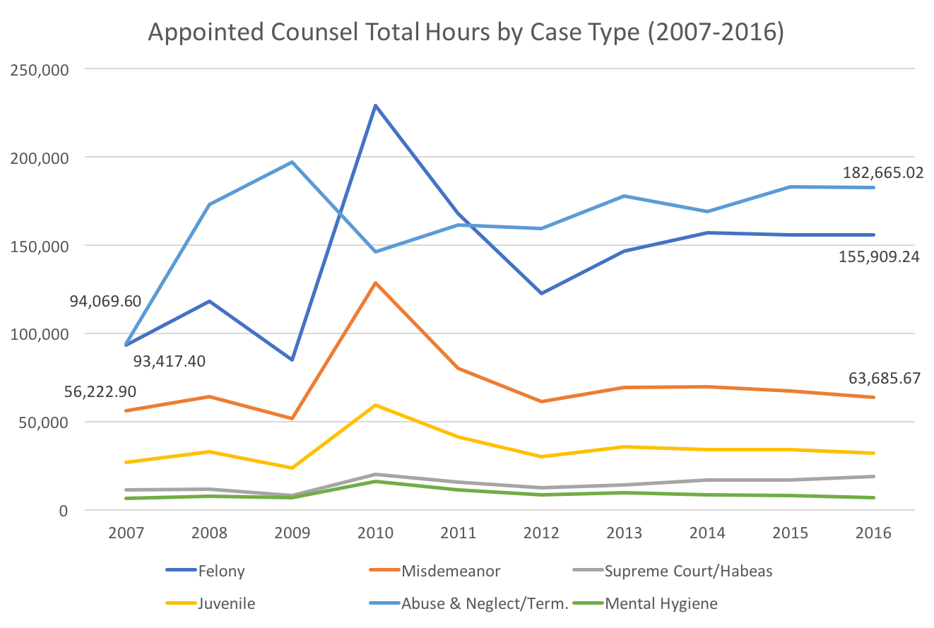
Figure 3
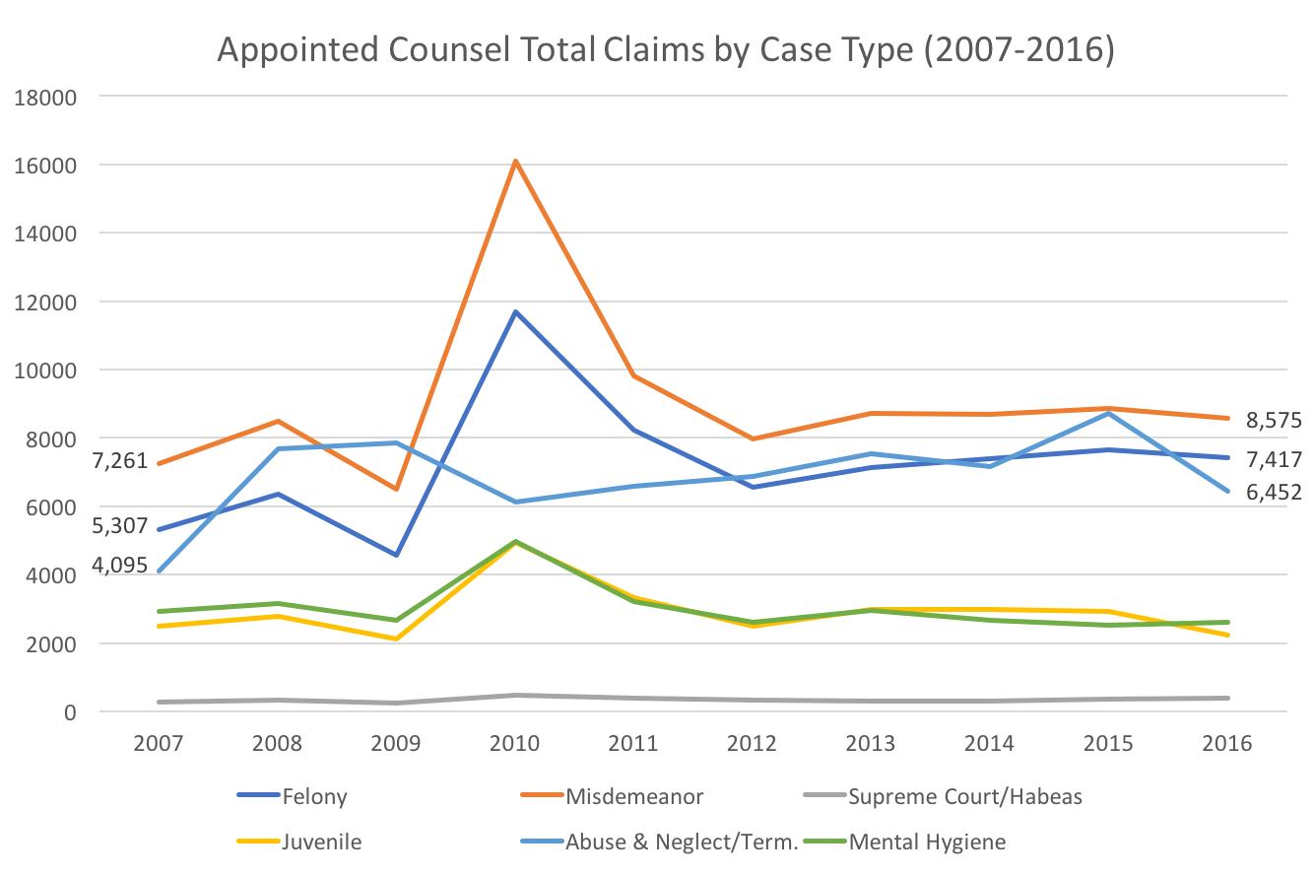
Figure 4
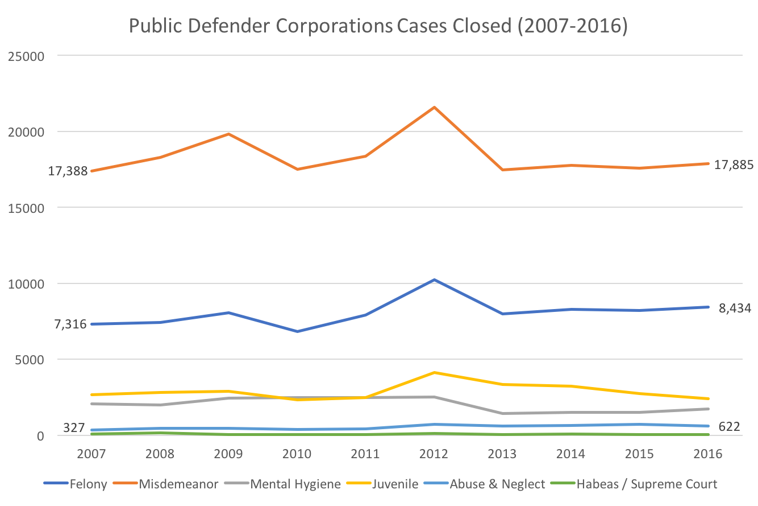
Figure 5

In addressing this questionable accounting custom, which has been notorious within the state’s criminal bar for some time now, the easy contention is to hold that lawyers are abusing Public Defender Services simply to line their pockets or recover for their private firm’s revenue losses. It is easy for the public and the legislature to be cynical towards lawyers about this epidemic because lawyers, by virtue of longstanding and unflattering stereotypes, are easy targets and scapegoats, for what is actually a more complicated and perennial problem: the system fails to provide reasonable compensation for services rendered in the spirit of the profession’s ethical obligations to provide decent and effective counsel to all citizens, no matter their ability to afford a decent defense.
The current compensation rates for Appointed Counsel in West Virginia are $45 an hour for out-of-court services and $65 an hour for in-court services. These rates have not changed since 1990. The current rates were set by the legislature at the order of the West Virginia Supreme Court of Appeals in Jewell v. Maynard, 181 W.Va. 571, 383 S.E.2d. 536 (1989). In that case, plaintiff Millard Jewell, a practicing attorney in Mingo County, successfully proved to the court that the low-rates and high volume of cases too which he was appointed were a violation of his due-process rights and barred him from effectively representing his appointed clients as well as paying clients. The decision to raise compensation rates as ordered in Jewell was a remedy revisited by the Court from a prior order in State ex. Rel. Partain v. Oakley, 159 W. Va. 805, 227 S.E.2d 314 (1976), which established for the first time in West Virginia, an hourly compensation rate for legal services on behalf of indigent defendants at $20 for out-of-court work and $25 for in-court work. The Court’s order in Partain was a direct response to the ineffectual $100/$200 per case flat-rate which had preceded it.
The same fundamental issues that prompted the Court’s rate-changing decision in Partain returned to the Court twelve years later – without any intervening rate adjustments -- in the Court’s 1989 decision in Jewell. Now, twenty-eight years after Jewell – again, without any intervening rate adjustments -- West Virginia is again facing the same issues that resulted in rate-changing orders from the Court in both of the prior cases. A cyclical pattern, is clearly emerging in the form of rigid compensation rates falling behind the demands of an inflating economy and thereby resulting in strained (if not outright refused) representation for indigent defendants and questionable fraudulent billing practices from some lawyers who are still willing to take the cases.
West Virginia is not alone in this problem. To varying degrees, almost every state is experiencing similar institutional crises within providing public defender services as the volume of criminal litigation continues to rise and the cost of litigation congruently increases along with it. Meanwhile, the respondent growth of the legal industry struggles to keep pace. Since the landmark United States Supreme Court decision in Gideon v. Wainwright, which required states to provide effective legal counsel for indigent defendants, the underlying attitude of the general public and their respective representatives in office has been a tepid approval for providing accused criminals with a cheap, if not inherently unfair, legal defense system. That unenthusiastic attitude typically results in grossly underfunding programs that are charged with providing those services, which in turn results in some attorneys using ethically questionable means to either (1) refuse to take further appointments, (2) overstate their legal services, or (3) reluctantly stay within honest parameters, but provide bare-minimum representation that does not meet the constitutional standards set out in Gideon.

The Value of Current Reimbursement Rates

There is a growing reluctance among members of West Virginia’s legal community to participate in public defender services. This is mostly the result of an outdated compensation rate so low that it does it does not reflect even the bare-minimum amount necessary to make the time required to provide effective counsel to indigent defendants cost-neutral for the attorney. Many of the state’s lawyers currently in practice are forced to refuse court appointments or dramatically cut corners to avoid taking a financial loss from the cases, despite a real understanding and deep conviction regarding its vital importance to society and a fair justice system. When the West Virginia Supreme Court of Appeals addressed this same problem in Jewell, it recognized several factors which substantiated the claims of the plaintiff:
- In the twelve years since Partain, the cost of living had doubled. The then-current compensation rate did not reflect the change in the economy’s inflation, which severely impeded appointed counsel’s ability to provide the quality of representation intended by the Partain Court.
- Overhead costs had increased as well. The maximum amount awarded to appointed counsel for direct expenses did not reflect the amount a private attorney would consider necessary to support a comparable case. This resulted in appointed counsel having to stretch their expense accounts well beyond what is typically considered normal cost-saving practices and often resulted in appointed counsel fronting their personal capital until the state reimbursed them, putting their own finances at a considerable and burdensome risk.
- Delays in reimbursement payments were putting some attorneys (as well as the state) in arrears to such a degree that otherwise willing attorneys were declining to to take court appointed cases.
To address the diminished purchasing power of the 1977 compensation rates set in Partain, the Court started with the $20/$25 figure and adjusted them as if they had maintained pace with inflation, using the Consumer Price Index (CPI), a common method of analysis widely used by economists and policy makers as a standard to determine the valuation of the dollar over time. If the state used the same method now to determine the value of the $45/$65 rate with a base year of 1990, then the current hourly rate in January 2018 would be about $85.78 for out-of-court work, and $123.90 for in-court work. Figure 6 illustrates what the compensation rates and overhead costs would be had they been adjusted for inflation every year since 1990.
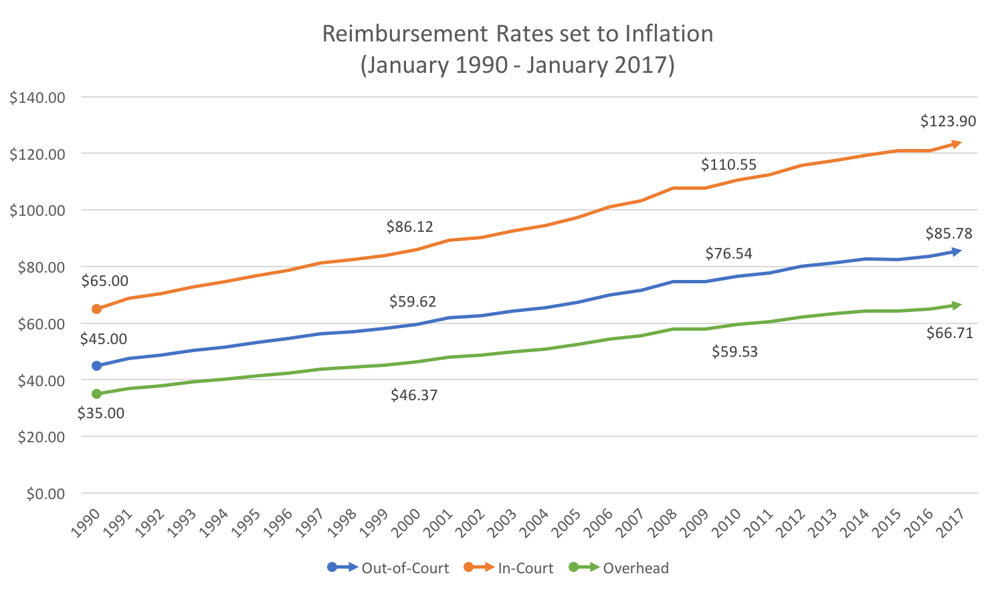
Figure 6
The deduction that can be made from this particular method of analysis is that Appointed Counsel is once again being paid about half of what their services were originally deemed to be worth. This is the same conclusion made by the Court in Jewell, when they reasoned that the cost of living had nearly doubled since the hourly compensation rates had been established in 1977.
The actual CPI for the $20 / $25 rate set in Partain equated to $42.53 / $53.16 for out-of-court and in-court compensation at the time Jewell was decided in July 1989. So, in requiring the slightly higher $45 / $65 rate, the Court also referred to the then-current rates of the federal system, which at the time were set at $40 / $60 for out-of-court and in-court work. Judge Neely concluded:

Although this floor, at first, may appear arbitrary, we have concluded that these rates are the minimum compensation constitutionally permissible based upon precedent in the federal system, a rough calculation of the current purchasing power of the fees established in 1977, and an adjustment for the fact that we are delaying the effective date of our order until 1 July 1990. (emphasis added).

In Jewell, the Court found that overhead costs for a private attorney were on average about $35 per hour. Modern surveys of private attorneys indicate that a typical private attorney will have on average of 50% of their hourly fee-rate consumed by overhead expenses. However, just taking the $35 per hour overhead rate found in Jewell, and adjusting it for inflation to January 2017 (Figure 5), equates to $66.71 per hour. This means that in 2018, if an attorney is spending a comparable amount of overhead on a case concerning an appointed client as they are with a privately represented client, then they are very likely taking a loss on that case just in overhead, regardless of whether the work is done in-court or out-of-court. It should not be surprising then to find a seemingly arbitrary increase in the number of hours claimed per case type by appointed counsel (Figure 3).
Additionally, overhead expenses have increased across the board with dramatic advancements in new technology used in doing criminal cases (e.g. DNA evidence production, costs of reference materials, computer research, malpractice insurance, etc.). The maximum expenses allowed in West Virginia are $3,000 for cases carrying a possible penalty of life imprisonment, and $1,500 for all other cases. This too, has not significantly changed since 1990. The most current CPI adjustment available in November 2017 would equate those maximums to $5,808.53 and $2,904.27, respectively. Therefore, not only are attorneys compensated at levels denoting half of the value of their public defender services, they are also expected to stretch the dollar almost twice as far in the course of their representation when compared to the same work being done in 1990.
Before costly litigation once again orders corrective measures, the legislature should consider proactively raising compensation rates for appointed counsel using economic modeling methods similar to those employed by the Court in Jewell. The legislature should also consider following the recent trend of other states who have increased compensation rates in the last decade, eliminated or increased maximums on expenses, or changed the authority for setting those rates from statutory mandate to administrative determinations by a state commission. The latter can more efficiently, appropriately, and consistently adjust reimbursement rates to recognize inflationary pressures free of recurring political obstacles. By following these leads, West Virginia is less likely to perennially jeopardize the constitutional mandate of Gideon in a fraught political process that pits well-meaning public service lawyers against well-meaning officials pressured to resist rate changes by an ill-informed public.

Indigent Defense Compensation in America

West Virginia is far from alone concerning this issue. Data from other state systems vary drastically, however, and are seldom studied in a comprehensive way, making it difficult to rank where West Virginia stands. The most reliable comparable data come from the Indigent Defense Counsel of the National Association for Criminal Defense Lawyers (NACDL), who surveyed all 50 states on the 50th anniversary of Gideon v. Wainwright in 2013. The last comprehensive study before that was done by the Spangenberg Group in 2007, and that study was fairly limited. The Spangenberg Group’s study did have an effect on certain states and prompted many of those states to amend their indigent defense systems. The more recent NACDL survey revealed that compensation rates across the country for appointed counsel are, by and large, still staggeringly low and wildly inconsistent with one another. Compensation for felony cases in the 30 states that have established a statewide compensation rate is typically less than $65 per hour, with some states paying as low as $40 per hour and other states paying as high $100 per hour, while still others have opted to increase or eliminate maximums.
There are three predominant types of indigent defense systems in America: a full-time public defender’s office, an appointed counsel plan, or contracts with indigent defense attorneys. Most states have a combination of at least two of these systems. The compensation rates within each system come in three predominant forms as well:
- uniform rates set by statute, regulation, or rule (30 states),
- rates set at the discretion of the presiding judge on a case-by-case basis (9 states), or
- through a contract between the state or a state agency and a private attorney (20 states).
The Federal Criminal Justice Act currently pays federal public defender attorneys $132 an hour with maximums as high as $10,000 for non-capital felonies. That figure is substantially higher than the majority of states. The lowest compensation rate in the country is in Wisconsin, at $40 an hour. Tennessee pays court-appointed attorneys $40 an hour for out-of-court work, while simultaneously paying court-appointed investigators a strangely higher rate of $50 an hour for out-of-court work.
West Virginia is not the only state with stagnant compensation rates, but it does maintain the second-oldest current compensation rate in the country. Alaska’s compensation rate is the oldest, enacted and unchanged since 1986. South Carolina has not changed its rate since 1993, and Vermont has resisted since 1994. Wisconsin increased their rate by $5 in 1995, but other than that, the rate has not changed in roughly 40 years. Hourly compensation rates in 10 other states, in addition to West Virginia, have not changed over the last decade: Alaska, Maryland, Massachusetts, Nevada, New Hampshire, New York, South Carolina, Tennessee, Vermont, and Wisconsin.
On the other hand, some states with statutorily set hourly-rates have taken the initiative to raise compensation for appointed counsel to more fairly reflect inflation:
- Alabama enacted a $70 hourly-rate in 2011, with maximums for expenses varying by offence; $4,000 for Class A felonies, $3,000 for Class B, $2,000 for Class C, and $1,500 for misdemeanors.
- Hawaii enacted a $90 hourly-rate in 2005, with varying maximums by offense; $6,000 for felonies, $1,500 for misdemeanors.
- Nevada enacted a $100 hourly rate in 2003, with a $2,500 maximum for felonies and gross-misdemeanors.
- Kentucky rarely uses appointed counsel anymore due to a more robust Department of Public Advocacy (equivalent to West Virginia’s Public Defender Corporation), but has proposed hourly rates of $100 for felonies and $75 for misdemeanors when appointed counsel is necessary.
It should be recognized that higher compensation rates do not automatically guarantee an incentive for lawyers to provide more effective legal counsel. Twenty-six states, including West Virginia, impose maximums on appointed counsel that effectively limit the number of hours an attorney can be compensated. The maximum number of compensable hours available for appointed counsel can be calculated by dividing the maximum fee by the hourly rate, and any number of hours above that figure reduces the actual hourly rate the attorney is compensated – creating a stronger incentive for lawyers to cease zealous advocacy as soon as they reach that compensable figure, which can jeopardize the case for an indigent defendant.
The chart below illustrates misdemeanor compensation rates and the corresponding maximums that formulate the total number of compensable hours for appointed counsel.
Misdemeanor Offenses – Maximum Limit / Hourly Rate = Compensable Hours
State | Maximum | Hourly Rate | Compensable Hours
New York | $2,400 | $60 | 40
Alabama | $1,500 | $70 | 21.43
Colorado | $1,000 | $65 | 15.38
Nevada | $750 | $100 | 7.5

Nevada has the highest hourly compensation rate in the nation overall, but when it comes to representing misdemeanors, the maximum compensation allowed is one of the lowest and pays lawyers for no more than 7.5 hours per case. New York has a much lower hourly rate but a much higher maximum, giving lawyers in that Bar plenty of time to resolve most misdemeanor cases, but for not much hourly compensation.
The same calculation for West Virginia concerning misdemeanors equates to about 33 compensable hours per case, but the average misdemeanor in FY 2016 amounted to only 7.5 hours (approximately) of time billed (Figure 7). With misdemeanors being relatively quick cases, attorneys are far less concerned with maxing out and stand to make on average about $340 per claim. However, with that same figure of $45 with a maximum of $1,500 for termination of parenthood/abuse and neglect cases, which take considerably more time to adjudicate (average 28.3 hours) because of the typical complexity of the circumstances involved in family law practice, Appointed counsel are going to be much more cognizant of the number of compensable hours they have before they start taking a loss on the case. Taking just the conservative figure of $45 an hour and multiplying it by the average number of hours claimed in termination/abuse and neglect cases equals $1,278. Because many of these cases involve a considerable amount of time in court and before a judge, the actual figure is likely very close, if not usually exceeding, the $1,500 statutory limit.
The same goes for non-life imprisonment felonies, and is especially true for the rare habeas corpus case and for cases that reach the Supreme Court of Appeals. When the stakes for the indigent are as high as they are in these types of complex cases, the last thing that should be concerning them is whether they can trust their appointed lawyer to maintain the same motivation throughout the entirety of the case. In abuse and neglect cases involving children, the very last thing the state should do is create any disincentive for zealous advocacy.
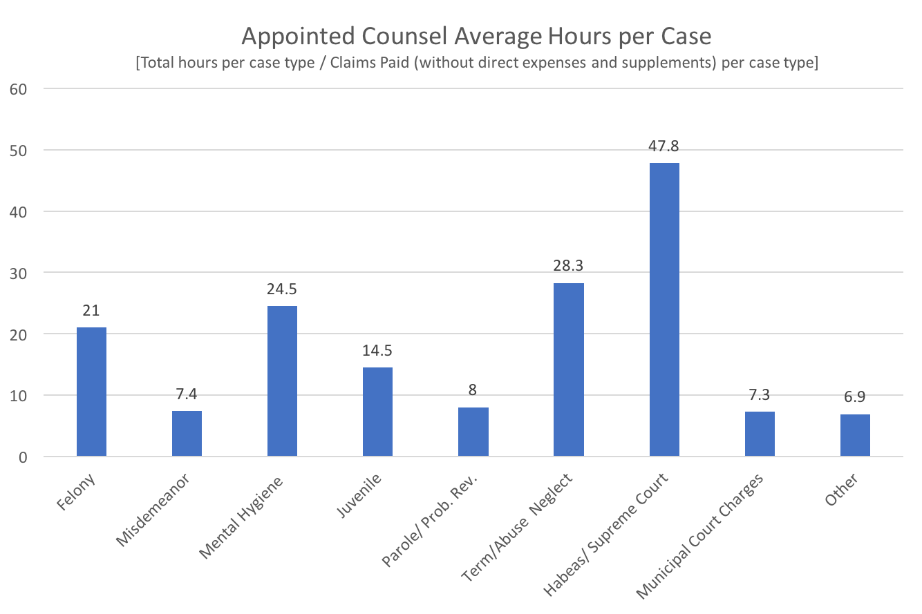
Figure 7
Of the 26 states that impose a maximum limit on compensation, 20 of them have a “soft cap” meaning that under exceptional circumstances, the maximum can be waived by a judge. This includes West Virginia, but there is little doubt that these limitations have a strong impact on the willingness of judges to award additional compensation. A potential conflict of interest arises when judges are given a high amount of control over additional compensation awarded, and can serve as a disincentive for lawyers to provide competent representation when they perceive – rightly or wrongly – that the judge is retaliating against the defense tactics of a lawyer who regularly appears before him or her. A judge can unilaterally decide what a case is worth by strictly enforcing caps and denying reimbursements for additional expenses that have been incurred.
There are some states that provide a decent example of compensation systems for appointed counsel. In 2000, South Dakota changed its compensation rate from a flat fee to an hourly rate of $67. In the same year, South Dakota also established an order that compensation rates would increase each year equal to the cost of living increase that state employees received that year. This was motivated in part by a state recognition that appointed counsel are similar in form to state employees, and the incentives for both are often parallel. By the time of the NACDL survey in 2013, the compensation rate in South Dakota reached $84 an hour, on par with what West Virginia’s out-of-court rate would have been had it followed suit.
Several other states have followed South Dakota’s lead in transferring the authority to change compensation rates and guidelines from statutory mandate, or court order, to the state’s respective indigent defense agency. Oregon did so in 2003, Montana in 2005, Georgia and Minnesota in 2007, Arkansas, Indiana, New Jersey, North Carolina, and North Dakota in 2012, followed by Connecticut in 2013, Missouri in 2016, and Ohio and Maine in 2017.
In 2008, Maryland set its maximum compensation rates to be equivalent to the federal compensation rates “as the state budget permits,” and increase annually in accordance to any increases in the federal rates. Maryland’s state budget, however, has rarely permited such an increase and the rates have remained stagnant for a number of years. South Dakota is still the only state to set rates annually for appointed counsel in congruence with the rate adjustment for the cost of living expenses of all state employees. The other states mentioned have attempted to bridge the gap by adjusting or eliminating maximums on expenses and billable hours, and some have made varying increases in compensation to achieve similar results.

Conclusion

West Virginia can expect to see a continued decline in appointed counsel participation until the State increases the compensation rate to reflect the rise in inflation over the past 28 years. A raise in compensation rates is needed -- not as an attempt to pay lawyers what they are actually worth by merit -- but to provide the constitutionally permissible minimum compensation. Lawyers in West Virginia take the oath of public service very seriously, but, at some point, participating in public defender services is so burdensome on their practice and personal financial viability that it becomes, in effect, a substantial charity to the judicial system.
The cyclical nature of compensation rates falling behind inflation and causing recurring problems for lawyers to make ends meet while providing competent counsel for indigent defendants will very likely happen again and again through the ensuing decades until the authority of that rate changes to a commission better suited to make adjustments consistently and dispassionately. The legislature does not annually debate the salaries of all state employees by category of employment. That would be a fraught and time-consuming endeavor that is best left to the administrations that employ them, who are generally more in touch with the demands of the economic and private industry pressures of their respective fields. Appointed counsel are essentially state employees when they are appointed to represent an indigent client at the behest of the State, and yet their compensation rates are subject to a political process that is disinclined to help either lawyers or criminal defendants.
West Virginia’s Public Defender Services are taking great strides to improve accountability and timekeeping practices to prove to the legislature that they are serious about solving this issue on their end. And those efforts will likely expose the relatively few attorneys who really are finagling their vouchers. However, improvements in timekeeping and accounting will do little to fix the underlying problem of why lawyers feel the need to misrepresent the number of hours they have devoted to an indigent case. That compunction derives from the low-rates of compensation, and until that is fixed, West Virginia can expect lawyers to find more clever ways to get around the new timekeeping improvements or worse yet, abandon public defender appointments all together – at least until the Supreme Court of Appeals is again forced to intervene, as it did in 1977 and 1989. West Virginians counting on their constitutional right to effective counsel are very likely suffering from the lackluster representation of financially strained or reluctant appointed counsel, just as they did in the times of Partain and Jewell. Yet many of the resulting costs for indigent defendants could be prevented by adopting an approach similar to what has been used in other states.

State Directory of Compensation Rate Authorities:

- Code of Alabama 1975 § 15-12-21
- Alaska Administrative Code Title 2 § 60.010
- Arizona Revised Statute § 13-4013(A)
- Arkansas Code Annotated § 16-87-211(b)(2)
- California Penal Code § 987.2
- Colorado: Chief Justice Directive 04-04
- Connecticut Public Defender Services Commission
- Rules of Criminal Procedure for the Superior Court of the State of Delaware Rule 44(c)(1)
- Florida Statute Annotated § 27.5304
- Code of Georgia Annotated § 17-12-22
- Hawaii Revised Statute § 802-5
- Idaho Official Code § 19-860(b)
- 725 Illinois Compiled Statutes § 5/113-3
- Indiana Code 33-40-8-2
- Iowa Code Annotated § 13B.4 (flat fee contracts) & Iowa Code Annotated § 815.7 (hourly rates)
- Kansas Statutes Annotated § 22-4507
Kansas Administrative Regulations 105-5-2, 105-5-6
- Kentucky Revised Statutes Annotated § 31.235
- Louisiana Revised Statutes Annotated § 15:147
- Code of Maine Rules § 94-649, Chapter 301
- Maryland Code of Criminal Procedure § 16-207
Maryland Administrative Code 14.06.02.06
- Massachusetts General Laws Annotated 211D § 11
- Michigan Compiled Law Annotated 775.16 § 11
- Minnesota Statutes Annotated § 611.215
- Mississippi Code Annotated § 99-15-17
- Missouri Revised Statutes § 600.042
- Montana Code Annotated § 47-1-216
- Revised Statutes of Nebraska § 29-3927
- Nevada Revised Statutes Annotated § 7.125
- New Hampshire: Superior Court Rules, Rule 47
- New Jersey Statutes Annotated § 2A:158A-7
- New Mexico Statutes Annotated § 31-15-7(11)
- New York County Law § 722-b
- General Statutes of North Carolina § 7A-498.5
- North Dakota Century Code § 29-07-0.1.1
- Ohio Revised Code § 120.041975
- Oklahoma Statutes Title 22 § 1355.8
- Oregon Revised Statutes § 151.216
- 16 Pennsylvania Consolidated Statutes § 9960.7
- General Laws of Rhode Island § 8-15-2
Supreme Court Executive Order No. 2016-06
- Code of Laws of South Carolina § 17-3-50
- South Dakota Codified Laws § 23A-40-8
Unified Judicial System Policy regarding court appointed attorney fees
- Tennessee Supreme Court Rule 13
- Texas Code of Criminal Procedure Article 26.05
- Utah Code Annotated § 77-32-304.5
- 13 Vermont Statutes Annotated Title 13 § 5205
Supreme Court Administrative Order No. 4
- Code of Virginia Annotated § 19.2-163
- Revised Code of Washington Annotated § 36.26.090
- West Virginia Code § 29-21-13(a)
- Wisconsin Statutes § 977.08
- Wyoming Rules of Criminal Procedure Rule 44(e)

Between 2007-2016, the total number of hours per case type for Public Defender Corporations was only reported in FY 2010 and FY 2011 Annual Reports.
The Court pegged its rates to those that were then being paid by the federal government to private defense lawyers in cases where the federal public defender had a conflict. The rates paid today by the federal system for private attorney services are $132 in noncapital cases and $185 in capital cases.
2012 Survey of Law Firm Economics by ALM Legal Intelligence
Rationing Justice: The Underfunding of Assigned Counsel Systems, John P. Gross, National Association of Criminal Defense Lawyers (2013).
Some states use a combination of the methods.

